* **Setup NodeJS**

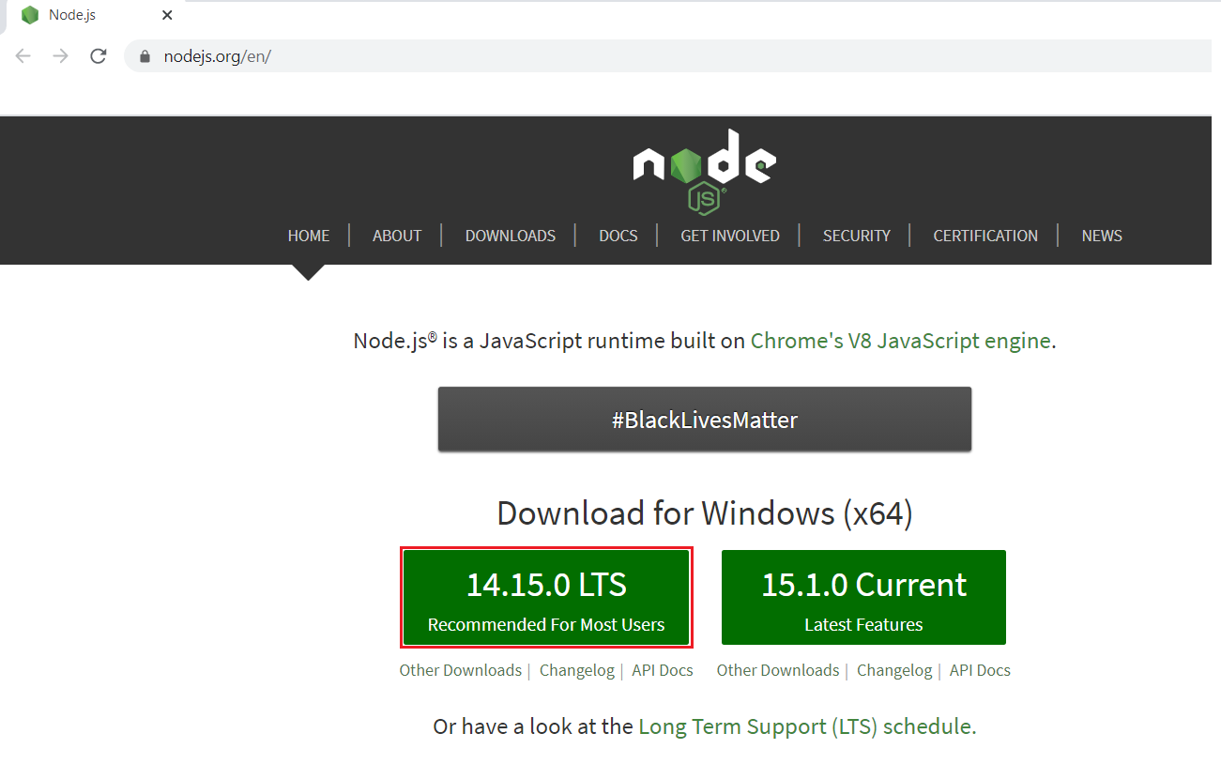 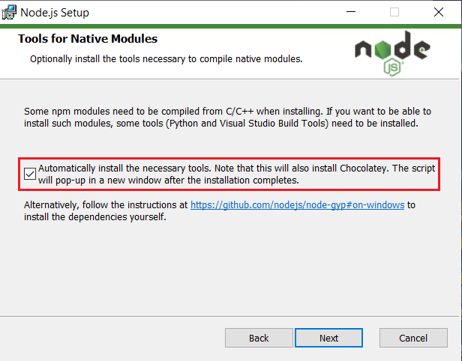

[*https://nodejs.org*](https://nodejs.org)

check version:

npm -v

node -v

* **Install TypeScript**

npm install -g typescript

* **Visual Studio Code**

<https://code.visualstudio.com/>

* **Reference**

<https://www.tutorialspoint.com/typescript/typescript_environment_setup.htm>